Assignment 3 Paxos running description

a1882972 Yuhan Xia

1. Demand: The paxos system need 10 terminals to run, 3 for proposers(member 1-3), 6 for acceptors(member 4-9), the another one is learner.
2. Late or immediately response and disconnected simulation:

Use random number in listen part of acceptors and proposers. If don’t use random number, it means that they can handle request immediately.

For members 1-3(Proposers), use different random number range to simulate their situation.

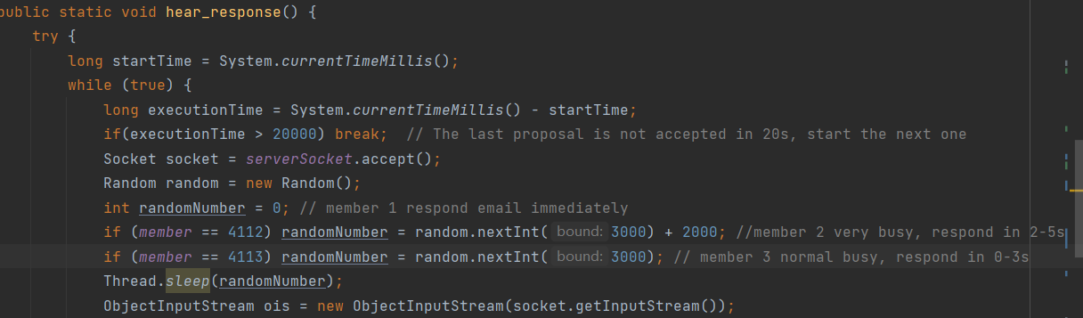

For members 4-9(Acceptors), use same random number range to simulate their common busy.

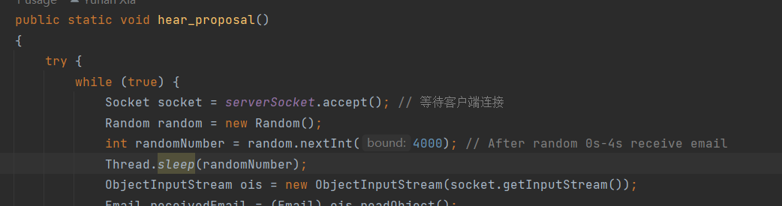

1. Proposal restart and end:

When a proposal is not accepted in 20s, the proposal will increase its proposal value by 1, and restart the proposal.

If a proposal is always not accepted in 20s after it’s prepared, it will increase proposal value, abd propose again and again, look like follows:

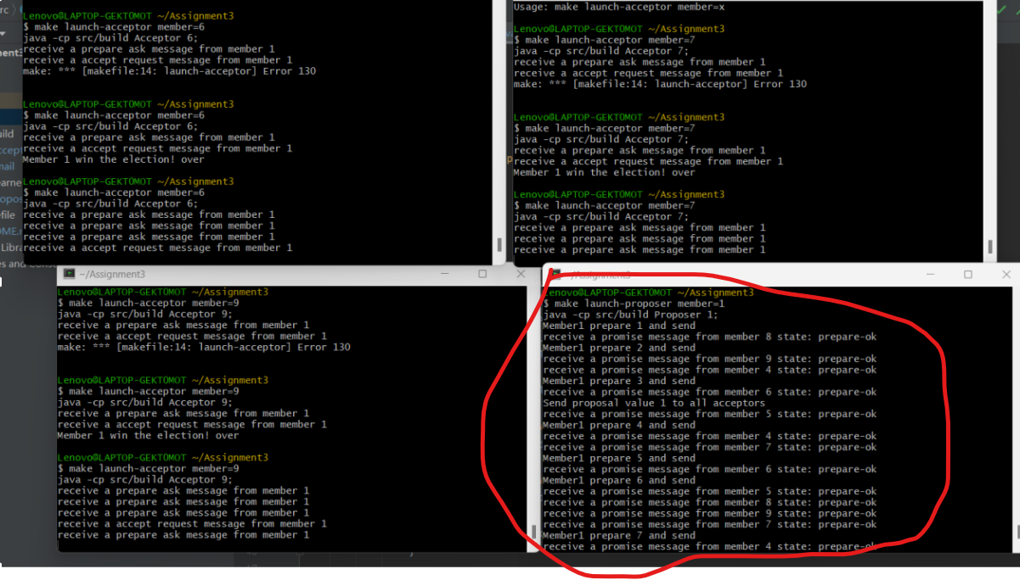When a proposal is accepted by majority(4 users), the learner will announce the outcome to all members, and all process stop:

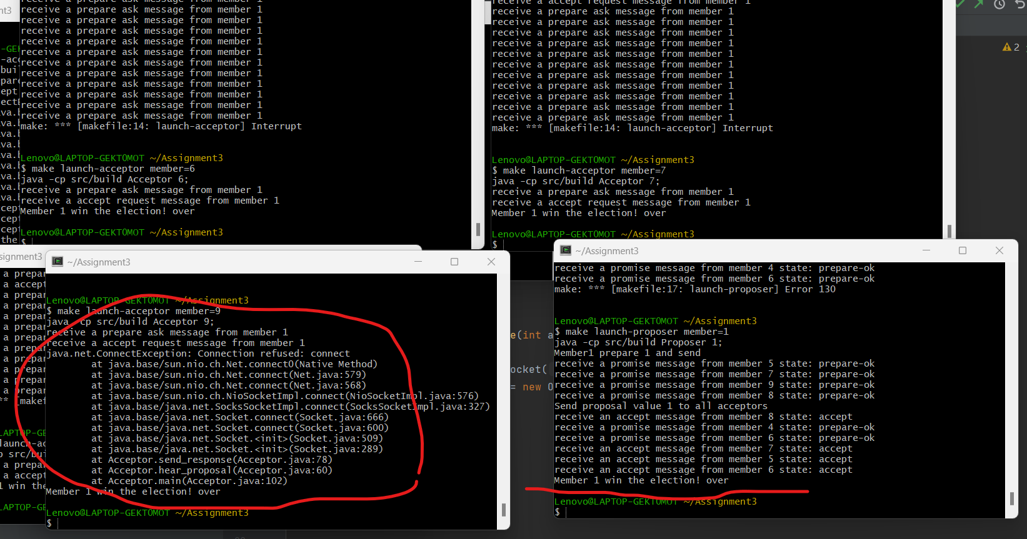

Note: The red circle in the picture above mean that acceptor 9 can not connect the proposer, but it will not influence the process, it will still continue.

1. Multiple proposers run simultaneously

The system allow multiple proposers run at the same time. The acceptor will handle until learner announce the outcome.

